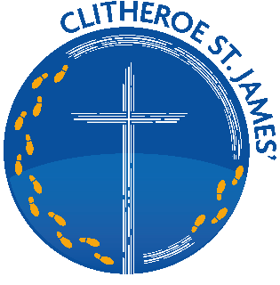
Key Instant Recall Facts
Summer Term 2
Rowan Class

I can recall square numbers up to 12² and their square root.
By the end of this half term, children should know the following facts. The aim is for them to recall these facts instantly.

1² = 1 x 1 = 1 √1 = 1
Key Vocabulary
What is 7 squared?
What is 7 multiplied by itself?
What is the square root of 144?
Is 30 a square number?

2² = 2 x 2 = 4 √4 = 2
3² = 3 x 3 = 9 √9 = 3
4² = 4 x 4 = 16 √16 = 4
5² = 5 x 5 = 25 √25 = 5
6² = 6 x 6 = 36 √36 = 6
7² = 7 x 7 = 49 √49 = 7
8² = 8 x 8 = 64 √64 = 8
9² = 9 x 9 = 81 √81 = 9
10² = 10 x 10 = 100 √100 = 10
11² = 11 x 11 = 121 √121 = 11
12² = 12 x 12 = 144 √144 = 12
Children should also be able to recognise whether a number below 150 is a square number or not.
Top Tips
The secret to success is practising little and often. Use time wisely. Can you practise these KIRFs while walking to school or during a car journey? You do not need to practise them all at once; perhaps you could have a fact of the day. If you would like more ideas, please speak to your child’s teacher.
Online games – You can use Education City songs and websites www.timestables.co.uk and www.timestables.me.uk
Cycling squares – At http://nrich.maths.org/1151 there is a challenge involving square numbers. Can you complete the challenge and then create your own examples?
Use memory tricks – For those hard-to-remember facts, www.multiplication.com has some strange picture stories to help children remember.

