
Key Instant Recall Facts
Birch- Year 3- Spring 1

Spring 1 Maths- Multiplication and Division
During Spring 1, children will continue to develop their knowledge of the operations of Multiplication and Division. They should already be familiar with various terms for multiplication and associated vocabulary, such as multiply, times, grouping and lots of. Similarly, they should be familiar with the different terms for division and associated terms, such as sharing and divide. Children practise using terminology for a range of given examples and it may be helpful to ask children how many equal groups of objects they can see or if they can put objects into equal groups, for a given number, drawing on their knowledge of their timetables. For example, because 20 is a multiple of 5, we know that we can share 20 into 5 groups. We will have 5 equal groups of 4. Children use counters and images of counters inside circles to represent these. Multiplication is the same as repeated addition (3 x 5 = 5 + 5 +5).
Look at the image below. There are ______ equal groups of _____.
How many different divisions, multiplications and additions can you think of to represent the total number of apples?
To work out the number of apples, we count up in multiples of _______.
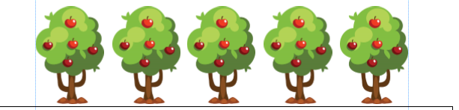
Children should aim to be fluent in their 3, 4 and 8 timetables during the Spring Term if possible, or by the end of Year 3 (along with 2, 5 and 10 timetables). They should be able to recall these with automaticity in any given order (e.g. 5 x 8 and 11 x 8). They should recognise that multiplications can be reversed (e.g. 4 x 3 = 3 x 4) and should use these to answer divisions (e.g. 12 ÷ 4 = 3 and 12 ÷3 = 4).
It may be useful to make times table posters and stick them up for children to use at home. Please see examples below.
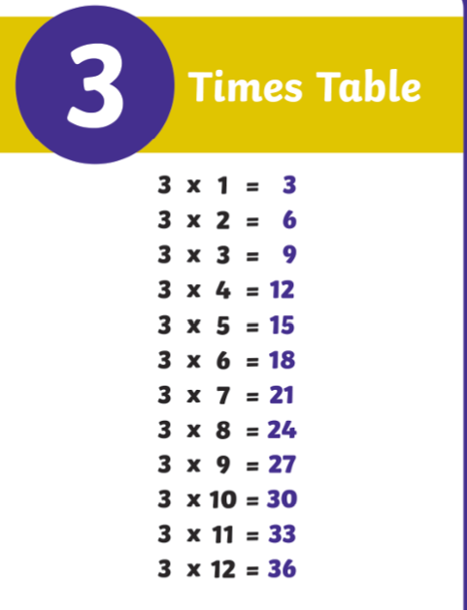
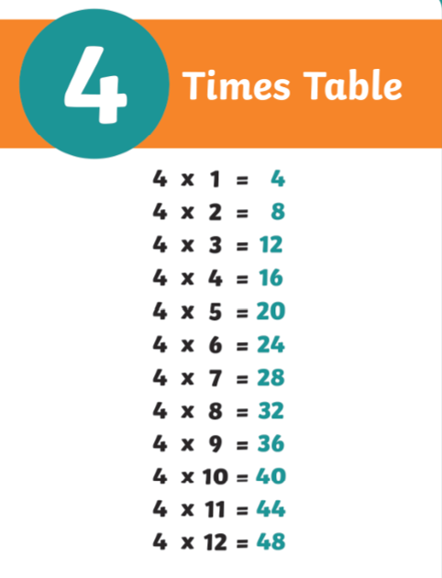
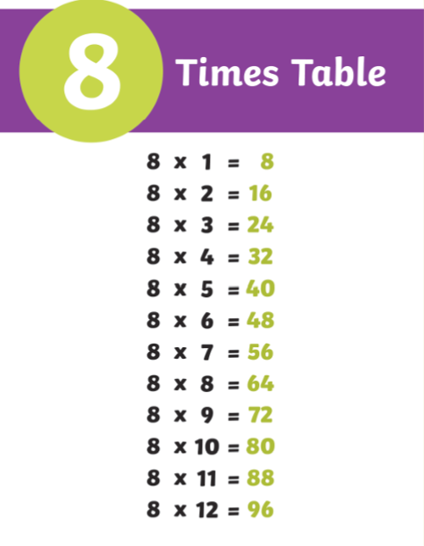

Children should be able to recognise patterns (e.g. all multiples of 4 are multiples of 2 but not all multiples of 2 are multiples of 4, multiples of 8 are double multiples of 4, multiples of 4 are even because 4 is an even number and multiples of 3 are always odd, then even). Please see below examples of questions that you can ask children.
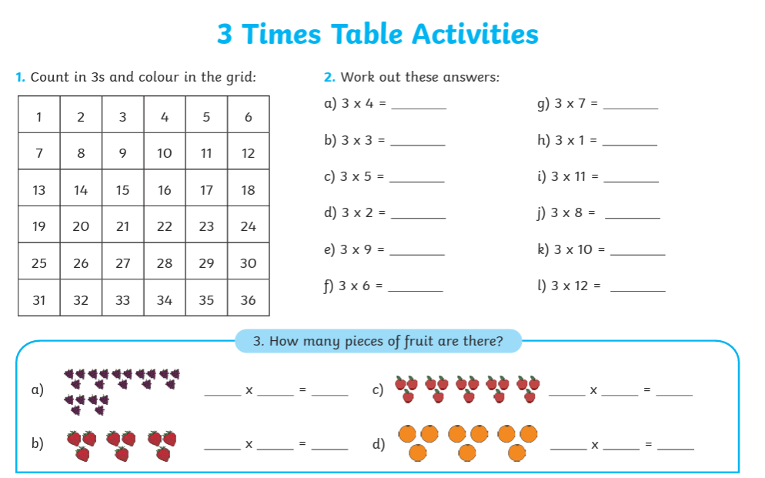
Playing games on TTRS will also support quick recall of times table facts which are useful in all areas of Maths.

Please see the links below for games, songs and quizzes:
https://www.bbc.co.uk/bitesize/articles/z97rdnb#z3r3xg8
https://www.topmarks.co.uk/maths-games/hit-the-button

The multiplication square below may be a helpful resource for children to use when working out multiplications.

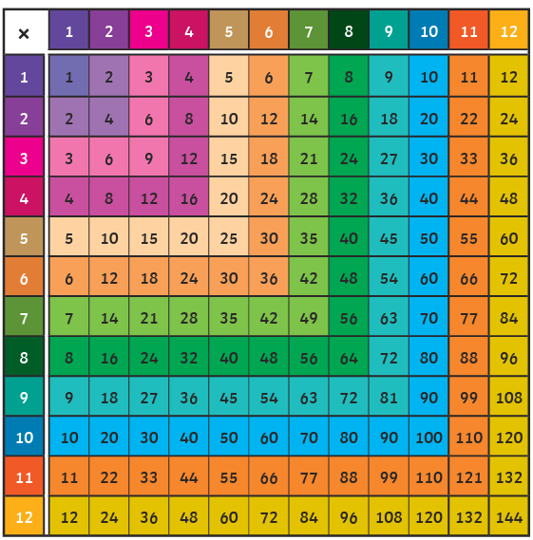
Knowledge of timetables will be essential for when children multiply and divide 2 digit numbers by one digit numbers, drawing on their ability to partition numbers and use related facts. (e.g. 23 x 10 can be partitioned into 20 x 10, which is ten times greater than 2 x 10, and 3 x 10. These multiplications would then be added together.
Use the place value counters and part-whole models to think about the questions below.
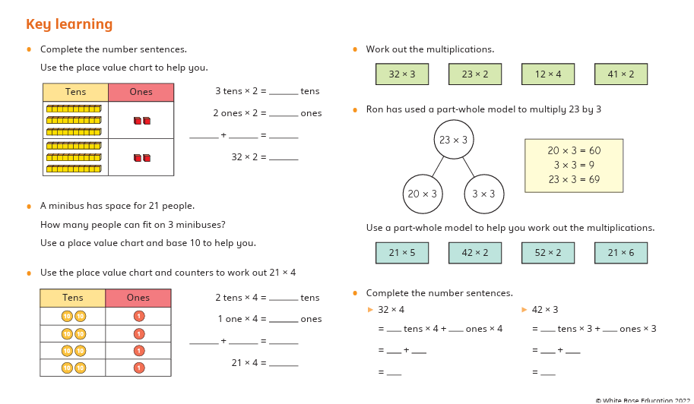
Spring 1 Maths- Length and Perimeter
In Year 2, children used either metres or centimetres to measure the length of objects. Children will revise these skills, initially using a ruler to measure objects in centimetres. They then combine both units of measurement, such as 1 m and 20 cm, for example by measuring the lengths of desks or the heights of children in the class. Children do not need to convert between metres and centimetres at this stage, and as they have not yet been introduced to decimals, lengths should remain in the format m and cm.
During this unit, children will measure in metres, centimetres and millimetres and a combination of centimetres and millimetres and metres, centimetres and millimetres. They will learn how to convert between equivalent lengths (metres and centimetres and centimetres and millimetres) and will compare lengths. They will add lengths and work out the total lengths of all sides of a shape (perimeter).
Children could try and practise measuring different objects and should record these with the correct unit of measurement (m, cm and mm), ensuring the start of the object is lined up at 0 on their ruler or measuring tape.

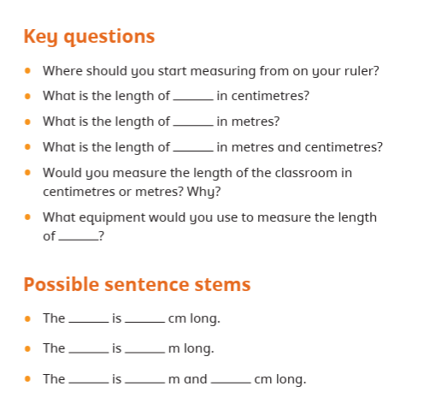
Children may wish to have a go at the questions below, carefully working out the distance between the two numbers if the end of the object is not aligned at 0.
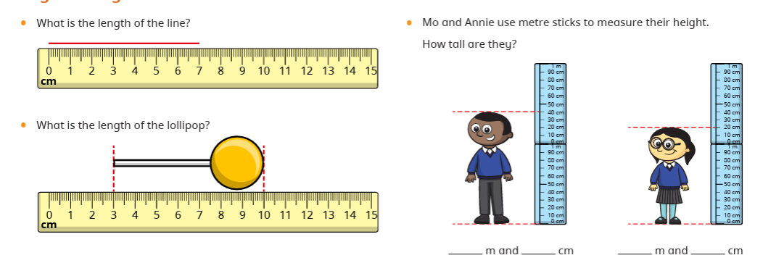

If 1 cm = 10mm and 1m = 100cm or 1000mm, have a go at the questions below.
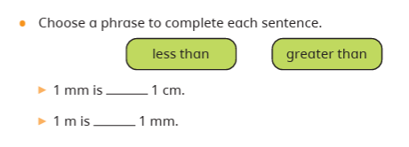
Can you think of an object you would measure in mm, cm and m?
