
Welcome to Birch Class



Hello and welcome back to school, everybody! I hope that you have all had a wonderful summer break and are feeling refreshed and ready for this academic year. My name is Miss Hargreaves and I am the Class Teacher of Birch, one of the two, Year 3 classes. Each morning, we will be supported in class by our Teaching Assistant, Mrs Rodgers. The children will be taught by Mrs Sharp on a Monday afternoon and by Pro-Sport on a Wednesday afternoon. We have lots of exciting learning instore for Birch! The children have made an excellent start to Year 3. Thank you very much to the children and their adults for enabling a smooth transition to the juniors. I hope that all children will be very happy in school this year, but if there is anything at all that you or your children are worried about, please don’t hesitate to speak to me after school. Children will enter school via the main door on the junior yard between 8:40-8:50 and will exit school via the external door in Hawthorn once the Hawthorn children have left at 15:20. If you need to contact me urgently or wish to speak to me at length, please make arrangements via the School Office. Texts, emails and consent forms will continue to be sent out via Teachers 2 Parents. Please check these regularly for information. Please see below some additional information.

Homework
This consists of weekly spellings, learning times tables and reading daily at home. All homework will be set on Seesaw, on a Friday, and should be completed by the following Friday. If anybody has any difficulties with Seesaw, please let me know. Please ensure that Home Reading Books and completed Records are returned daily to enable us to monitor reading and to allow us to read with children in school. Relevant logins and Reading Books will be sent home shortly.
Times Tables
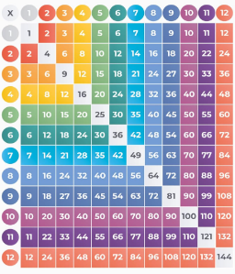
Learning times tables is a priority in Lower Key Stage 2. Children starting Year 3 should already know their 2, 5 and 10 times tables. By the end of Year 3, they should also know their 3, 4 and 8 times tables. The best way for children to learn them is for them to practise for 10 minutes each day. Children will be provided with Times Table Rock Star (TTRS) logins shortly, but you may find the links below useful too. There are also a range of songs and rhymes on You Tube to help children recite their times tables.
Top Marks- Hit the Button Game:
PTO
https://www.topmarks.co.uk/maths-games/hit-the-button
BBC Bitesize- Time Table Games and Songs:
https://www.bbc.co.uk/bitesize/articles/z97rdnb

Water Bottles and Healthy Snacks
Please send children in with a labelled water bottle and healthy snack each day (e.g. fresh or dried fruit). Due to allergies in school, please refrain from sending any nuts or nut-based products into school. Junior children eat lunch at the later time of 12:30, meaning some children may get a little hungry if they don’t bring a snack. Unfortunately, snacks are not provided in the Juniors.

Equipment
All stationery is provided in school, meaning we ask that children do not bring anything additional into school (e.g. pencil cases and toys etc). Please keep special belongings safe at home. On a Friday, if time allows, we will have an opportunity for children to Show and Tell. On this day, if children would like to bring a small object into class, such as a certificate, photograph, souvenir or craft, they are more than welcome. We will keep these safe in our box. However, please refrain from sending toys in. Alternatively, they could share something with the class, such as news of an event.
PE Days and Swimming
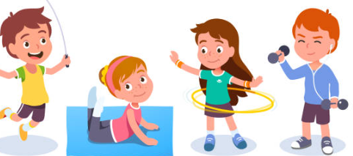
In Birch, our PE day is Wednesday. PE Kits will remain in school at all times and will be sent home to be washed at regular intervals.


Birch will also be going Swimming from 11/09/2025 to 5/02/2025. This is a weekly lesson at Ribblesdale Pool. Our Swimming day is Thursday. A letter has been sent out with additional information. A consent form for children wishing to wear goggles is found at the bottom of this letter. We ask that children wear their swimwear underneath their uniform on this day to maximise the time that children have in the pool. Each Thursday, children will need to bring a bag with a towel and underwear. Please do not send any toiletries. Thank you.
Please make sure that long hair is tied back and earrings have been removed or covered before children come to school on a Wednesday and Thursday. Full, school uniform should be worn on both days too.

I am really looking forward to continuing to get to know you and your children throughout this school year. Thank you for your support.
Miss Hargreaves

