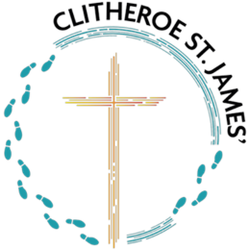
Spanish Curriculum Map
2024-5 Cycle A: All classes year 1 of scheme
 | Autumn 1 | Autumn 2 | Spring 1 | Spring 2 | Summer 1 | Summer 2
LKS2 / UKS2 | Greetings with puppets | Spanish numbers and ages | Pets | Classroom objects | Dates | Journey round Latin America

2025-6 Cycle B: year 2 of scheme
 | Autumn 1 | Autumn 2 | Spring 1 | Spring 2 | Summer 1 | Summer 2
Year 3 | Where do you live in Spain. | Shapes and colours | At the Spanish Market | Weather | Spanish Celebrations | The Amazon Rainforest
Years 4, 5, & 6 | Clothes | Free time activities | School Life | Shopping in Spain | Maya city treasure Hunt | Household tasks in Spanish

See next page for curriculum cycles when scheme has fully rolled out across school.

2026-7 Cycle A
 | Autumn 1 | Autumn 2 | Spring 1 | Spring 2 | Summer 1 | Summer 2
LKS2 | Greetings with puppets | Spanish numbers and ages | Pets | Classroom objects | Dates | Journey round Latin America
UKS2 | Describing family and friends | Spanish Portraits | Shopping | Household tasks | A trip across Spain | Saving South America

2027-8 Cycle B
 | Autumn 1 | Autumn 2 | Spring 1 | Spring 2 | Summer 1 | Summer 2
LKS2 | Where do you live in Spain? | Shapes and colours | At the Spanish Market | Weather | Spanish Celebrations | The Amazon Rainforest
UKS2 | Food and Drink | Sports | Clothes | School life | Free time in Spain | Maya city treasure hunt

