**K**ey **I**nstant **R**ecall **F**acts

Summer Term 1 2023

Year 3 Birch Class

**KIRFS**



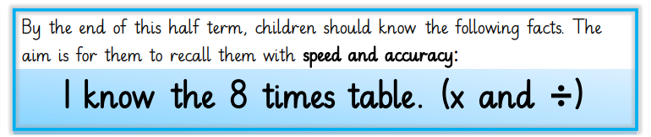

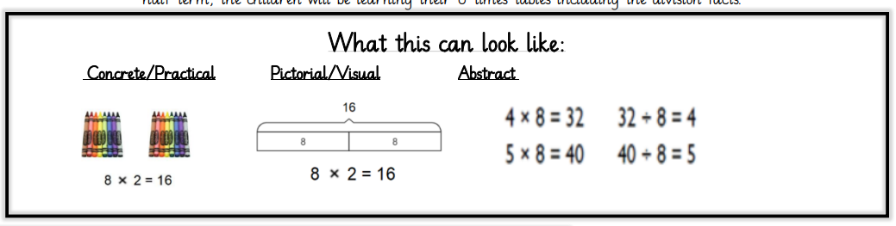

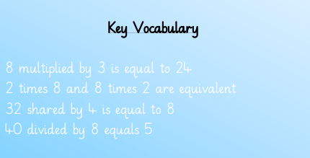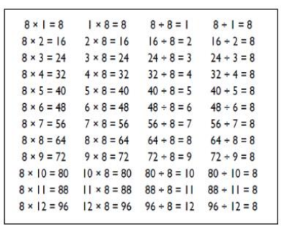

Practice on Times Tables Rock Stars or Hit the Button

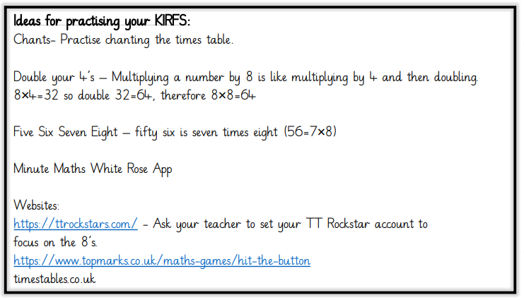

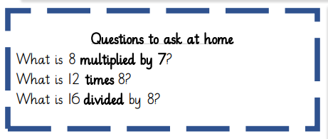

Remember also to keep practising times tables and division facts from Y2 (2, 5 and 10x ) and in Y3 (3 and 4 x) so that they can be recalled at speed.

Children should also be able to recognise whether a number below 150 is a square number or not.

**Top Tips**

The secret to success is practising **little** and **often**. Use time wisely. Can you practise these KIRFs while walking to school or during a car journey? You do not need to practise them all at once; perhaps you could have a fact of the day. If you would like more ideas, please speak to your child’s teacher.

Online games – You can use Education City songs and websites www.timestables.co.uk and www.timestables.me.uk

Cycling squares – At http://nrich.maths.org/1151 there is a challenge involving square numbers. Can you complete the challenge and then create your own examples?

Use memory tricks – For those hard-to-remember facts, www.multiplication.com has some strange picture stories to help children remember.