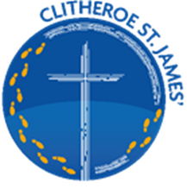
VISION FOR MATHEMATICS

Our school vision statement says that we will be:
Vision Acronym | B | O | L | D
We will: Believe Be Open Love Be determined

We will explicitly model, teach and inculcate the following learning behaviours which are directly applicable to mathematics:
Learning behaviours | Believe  Self-belief (with hard work I can achieve) | Open  Openness to different approaches and ways of thinking etc | Love Learning  Love learning | Determined  Determination (never give up)

Our mathematics curriculum is designed to be:
Curriculum | Broad and Balanced  A wide range of subjects and topics are taught allowing pupils to discover their own interests and talents | opportunities for all  Through careful sequencing and delivery of learning we maximise opportunities for all pupils to achieve | Love of learning  We want pupils to love learning. To feel the “buzz” of learning something new or struggling hard until you have learned a new skill. | Deep  Pupils are encouraged to think hard, to reason and apply their learning. There is depth to our curriculum offer.

Our vision for mathematics fits within our overall vision for pupils at our school. We see mathematics as integral to all aspects of life. With this in mind we endeavour to ensure that our children at St James’ develop a healthy and enthusiastic attitude towards mathematics and see its importance in their own lives, their future and in the world around them.
At St James’ Mathematics is a subject that all children can learn and enjoy.
We believe our children can be confident mathematicians, well equipped with skills to calculate, to reason and to solve problems and be resilient learners, seeing any mistake as opportunity to learn and improve.

