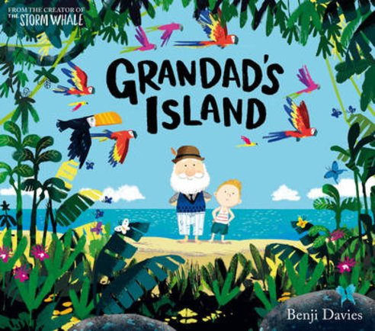
Adventure!
Oak Class – Spring term 2
Reception and Year 1

Our theme this term in Oak Class is “Adventure”. We will be reading stories with fantasy settings and
writing our own adventure sentences and stories. We will also be looking at traditional rhymes and instructions as part of our English lessons.
Year 1 History lessons will focus on changes within living memory. We will look at our own memories and how we can make memories.
In RE we will be talking about Easter and the important parts of the Easter story.
Reception phonics lessons will continue through phase 3, looking at further digraphs such as; ar, or, ur and reading and writing two syllable words.
Year 1 children will continue to work on alternative pronunciation of graphemes in phase 5. We will also recap and consolidate the tricky words we have taught so far.
Reception children will continue to build their fine motor skills and use the sounds they know to write letters, words and sentences.
Year 1 children will continue to add some detail to their writing and develop their handwriting.
Maths sessions and activities for Reception children will focus on representing and composing numbers up to 10. We will be looking at 3D shapes and investigating length, height and time.
Year 1 children will continue to develop place value knowledge and addition and subtraction methods in their maths lessons and looking at measuring length, height and time.
For further information regarding our curriculum please see the website page.
PE sessions will still be on Tuesday afternoons. Please send your child into school in their PE kit.

Homework and Reading at home
Every half term in year 1 we send an optional homework grid and a KIRFS sheet. Please see attached letter. Completed work can be brought in or uploaded onto see-saw.
Reading books will be changed on a Tuesday and Friday.
Children in Year 1 will be given spellings linked to the phonics sounds they have learnt, on a Monday to practise for a test on Friday.
Thank you for your ongoing support,
Mrs Butterworth and Mrs Woodward

