Educational Programme for Understanding the World | 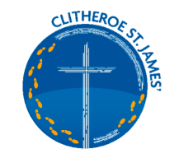  KNOWLEDGE AND UNDERSTANDING OF THE WORLD  PEOPLE, CULTURE and COMMUNITIES  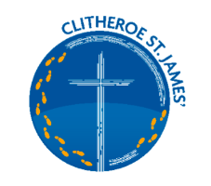
Understanding the world involves guiding children to make sense of their physical world and their community. The frequency and range of children’s personal experiences increases their knowledge and sense of the world around them – from visiting parks, libraries, and museums to meeting important members of society such as police officers, nurses, and firefighters. In addition, listening to a broad selection of stories, non-fiction, rhymes, and poems will foster their understanding of our culturally, socially, technologically, and ecologically diverse world. As well as building important knowledge, this extends their familiarity with words that support understanding across domains. Enriching and widening children’s vocabulary will support later reading comprehension.
Key Learning Linked to People, Cultures and Communities
CULTURES AND BELIEFS
• Communication – express feelings, give opinions and reasons. Comment on significant events in own lives, talk about their family, friends and the local community. Know about how people are similar, how people are different in gender, language, ethnicity, religion, culture and SEND. Use language skills to share experiences, ideas, give explanations, make suggestions, choices and decisions, either verbally or nonverbally.
• Respect – themselves, special things in their own lives, other people including their ideas, feelings, beliefs, culture, possessions.
• Observe – look closely and consider their own culture and religion and that of the people in their own community. Look closely at and observe the lives of people in communities in other countries within the world.
• Describe – culture and religion in relation to themselves, friends, family, and other people within their community based on their own experiences, events, objects or artefacts. Talk about and describe features of their own lives, talk about and describe features of the lives of people in their own community and of people in other countries across the world.
• Compare - recognise the similarities and differences in culture and religion between them and other communities. Look closely at and make comparisons between this country and the lives of people in other countries within the world.
• Research – show curiosity and interest, find out about people within their own community and in other countries - special places and events or objects – through non-fiction texts, stories, visitors, celebrations - explore and ask different types of questions, examine possibilities, consider alternatives.
• Vocabulary – language of tolerance, respect and co-operation.
GEOGRAPHICAL DEVELOPMENT
• Communication - talk about the features of their immediate environment and other places – familiar places and those they have learnt about and the differences between environments.
• Mapping - recognise, know about and describe features of different places including their immediate environment, other familiar places and places they have learnt about through non - fiction texts, stories, maps, visits, visitors, etc.
• Fieldwork - look closely at similarities and differences between their immediate environment and different places they have visited, learnt about through books or websites, etc. Talk about what features are the same and what are the differences.
• Enquiry - comment and ask questions about their immediate environment, other places which are familiar to them, and places they have learnt about.
• Use of Technology - use technology and IT equipment (e.g. camera, iPad, video/video clips, apps, visualisers or the internet) to make observations or find information about their immediate environment, different locations and places.
Vocabulary for Culture and beliefs
Language of tolerance, respect, co-operation, work together, trust, fairness, equality, similarity, likeness, safety, share, take turns, listen, consider, think, talk, discuss, different, same, admire, value, patience, acceptance, choice, chose, pick, diversity, variety, range, mixture, determination, perseverance, firmness, result, freedom, independence, positive mindset.
Expressing feelings, happy, cheerful, glad, excited, joyful, sad, miserable, gloomy, angry, worried, anxious, frightened, scared, nervous.
Vocabulary for Geographical Development
Human features- buildings, house, school, shops, church, mosque, farm buildings, stables, village hall, garage, swimming pool, markets, museums, railway station, bus station, garden centre. Roads – lane, street, motorway, cul-de-sac, avenue, roundabout, traffic signs, Boundaries- fence, wall, gate, railings. Town, countryside, coast, seaside, park.
What this Looks like in EYFS
Autumn 1
Where do I belong? Me and my world
Geographical Development
Getting to know my new school, Where are places in my school? How do I get there? Where do I need to be? Can I find things in my classroom? Do I know where my belongings are kept? Naming areas in school? Can I put things away in the correct place? Take pictures of BIG HOO in different places in school towards the end of term do the children know where he is?
People, Culture and Communities
Harvest, being thankful and appreciating what we have, discussion around the food bank and sharing what we have. Is it fair?
Who works in my school? Why are they important?
What is it like to belong to our school (Mission Statement)
St James’ Journey
What is special to me (Family and friends)
Similarities and differences between us, Likes and dislikes and interests, My Favourite things
What is my family like? How is my family different to my friend’s family? How is my family similar?
Introduction of the rules BE RESPECTFUL, BE SAFE, BE A GOOD LEARNER
Classroom behaviour – How to make friends.
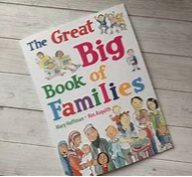

RE FOLLOWS THE PLANNING FROM THE DIOCESE
I Am Special
Link to World Faiths: Islam
Harvest

Autum 2
What do we celebrate? Sparkle and Shine
Geographical Development
Small world area in the classroom
Talking about the seasons and the weather, observing the trees changing, becoming bare, changes in the daylight hours during Autumn darker mornings and darker earlier in the evenings. How does the weather make us feel (wrapping up for the Eco Zone, feeling warm when we come in from playtime) encourage vocabulary how does the weather make their body feel?
Story maps following a story using a story map.

People, Culture and Communities
Autumn celebrations, Children might talk about halloween and bonfire night, what they do to celebrate these events. Does everybody celebrate? Discuss fireworks and safety and why they are used in different celebrations. Diwali will be covered this half term the story of Rama and Sita is read and discussed children complete creative work and talk about the Hindu Traditions (BBC Clips Diwali, Let’s Celebrate CBeebies Diwali) How is Diwali celebrated? Who celebrates Diwali? We are then running up to the Festival of Christmas – we talk about Birthdays and children talk about how their family celebrate these traditions. We also look at Christmas Traditions from other cultures. Do we all celebrate in the same way?
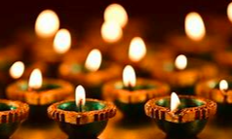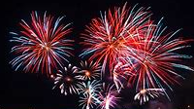
RE FOLLOWS THE PLANNING FROM THE DIOCESE
Special People Link to World Faiths:
All World Faiths
Christmas:
Link to World Faiths: Hinduism

Spring 1
Where am I going and how will I get there?
Geographical Development
Talking about the location of their home do they know their address? – locating using google maps- Children enjoy finding their homes and talking about them. Where can they travel to by foot in Clitheroe. Locate places that are familiar to them in their knowledge. Can they talk about their journey to and from school, what places do they pass? (human and physical features) Talk about Clitheroe what is Clitheroe like? It is a town. What is a town? Read “ Bear about Town” Use the maps in the books to locate places. Use the BEE BOTS and the High Street Mat to navigate the BEE BOT down the high street. Make a journey string for Bear’s Journey. Then ask children to create a journey string Harry’s Journey around Clitheroe. Talk about the Castle. Children talk about the Human and Physical features at the park. Children attempt to draw maps, look at photographs of places in Clitheroe to describe and talk about. Children use the construction area to build a town (Clitheroe or their own town) what is in their town talk about their model town, help them to write labels for the buildings in their town. Use pictures of places in clitheroe to enhance the construction area.
Move on to other ways to travel – Use the Train ride June Crebin – Map the journey
Use Rosie’s walk – Children create a map of places Rosie the Hen went to – Retell the story using features in school – Rosie’s walk at st James’
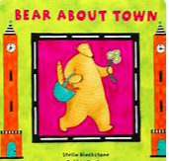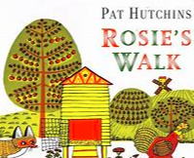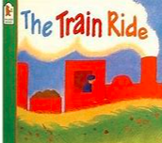
People, Culture and Communities

RE FOLLOWS THE PLANNING FROM THE DIOCESE
Stories Jesus Heard
Stories Jesus Told

Spring 2
What do I like to eat and is it good for me?
Geographical Development
Seasonal changes – Spring – What is the weather like? What is it like in the Eco Zone at this time? What is growing? Find signs of Spring and talk about the location of what they have found? What plants have you spotted, where are they?
When reading Handas Surprise look at the village Handa lives in. What is her home like? Where does she live? What is Kenya like? What animals does she see walking to her friends? Would you see those animals where you live? Look for Kenya on a map of the world. Locate where we live. Create a kenya small world area – children can use props to retell the story.
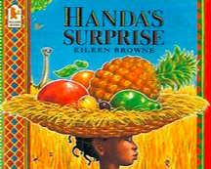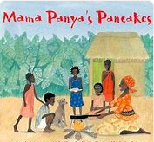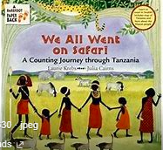
People, Culture and Communities
Handa’s Surprise – discussion about another culture and a village in Kenya- Make links to Kings Highway School in Eldoret
Food for festivals and celebrations – Explore Eid (Mrs Zulfi, and any children celebrating in school)
Mrs Zulfi to make some chapatti with the children and Indian cuisine
What do we eat at Easter. Easter Traditions – Hot cross buns, simnel cake, easter eggs. On a food theme, but also Easter Customs. How do we celebrate?
Explore Veganism, Vegetarianism and Food Intolerances – Exploring differences in how we eat and respecting views about food and eating.
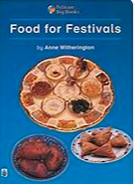
RE FOLLOWS THE PLANNING FROM THE DIOCESE
Easter

Summer 1
Are animals like me?
Geographical Development
Where do animals live? Animals that live in hot/cold countries? Where are hot and cold countries? What are these places like?
Create hot and cold worlds in the small world area
Treasure hunt type activities in the outdoors, number hunts, phonics hunts, finding animals hunt
Town mouse and the Country Mouse story- what was the difference between the town and the country?
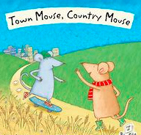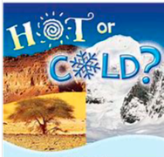
People, Culture and Communities
Reinforce the idea of making choices – the town mouse and the country mouse made choices. When deciding on a pet we have to make a choice but think carefully about the choices we make.
When talking about disability and dogs helping visualy impaired and other individuals talk about the importance of accepting that we are all unique, but important and everyone deserves respect.
Talk about the impact that humans are having on the world and animals, how are we spoling our planet, what do we need to do to help the planet, care for the planet?
RE FOLLOWS THE PLANNING FROM THE DIOCESE
Special Places

Summer 2
What does the Summer bring?
Geographical Development
Forest School sessions with Forest School teacher
Seasons – Changes in the weather and in the environment.
Where would you have a picnic? seaside, woodland, park- what are these places like? Where do the children think would be the best place for a picnic? Why? What might you find at the seaside/ in the woods/ at the park? (human and physical features)
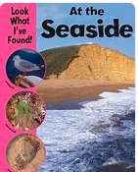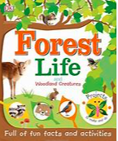
People, Culture and Communities

RE FOLLOWS THE PLANNING FROM THE DIOCESE
Special Times

EARLY LEARNING GOAL (ELG)
Children at the expected level of development will: - Describe their immediate environment using knowledge from observation, discussion, stories, non-fiction texts and maps; - Know some similarities and differences between different religious and cultural communities in this country, drawing on their experiences and what has been read in class; - Explain some similarities and differences between life in this country and life in other countries, drawing on knowledge from stories, non-fiction texts and – when appropriate – maps.

This sets out possible learning and intentions our plans are flexible as our children’s learning is often driven by their interests and certainly planned around their needs.

