Educational Programme for Understanding the World | 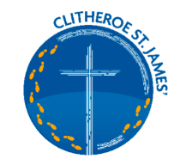  KNOWLEDGE AND UNDERSTANDING OF THE WORLD  THE NATURAL WORLD/WORKING SCIENTIFICALLY  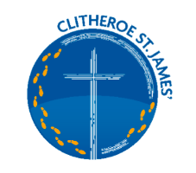
Understanding the world involves guiding children to make sense of their physical world and their community. The frequency and range of children’s personal experiences increases their knowledge and sense of the world around them – from visiting parks, libraries, and museums to meeting important members of society such as police officers, nurses, and firefighters. In addition, listening to a broad selection of stories, non-fiction, rhymes, and poems will foster their understanding of our culturally, socially, technologically, and ecologically diverse world. As well as building important knowledge, this extends their familiarity with words that support understanding across domains. Enriching and widening children’s vocabulary will support later reading comprehension.
Key Learning Linked to the natural world – working scientifically.
• Explore/Observe - look closely at/notice features in the natural world including animals and plants, weather and seasons, and natural materials e.g. water, ice, sand, stones, etc.
• Describe - talk about what they notice/observe in the natural world, e.g. features of animals, plants, natural materials, seasons, weather, etc; talk about changes they notice and changes over time, based on real experiences or books read to them at home or school.
• Record - draw pictures e.g. observational drawings of plants, mini-beasts, take photographs, make models or record in scrapbooks.
• Questioning - show an interest in and be curious about the natural world; ask questions about what they notice/observe or changes that occur, e.g. changes in plants throughout the seasons.
• Explain - talk about what they know and what they have learnt about the natural world. Talk about why things happen/occur in relation to different processes e.g. ice melting, seasonal changes.
• Research - talk to people (visits/visitors/family), think of questions to ask to find out about plants, animals, seasons, processes ; use first hand experiences/use secondary sources, (e.g. books, photographs, internet).

• Equipment and measures - use senses/use simple equipment to make observations, (e.g. magnifiers, pipettes, egg timers, digital microscopes, etc).
• Compare/sort/group/identify/classify: notice similarities, notice differences in the natural world, including plants and animals; talk about what they know and understand about similarities and/or differences, e.g. in relation to the natural world around them and other environments they have learnt about through real experiences or books read at home or school.
• Test - make suggestions, show resilience, work with others.
• Vocabulary - use simple vocabulary to name and describe objects, materials, living things and environments.
Children need regular opportunities to experience, develop and use vocabulary related to the world around them. Adults should provide opportunities to teach and model the use of vocabulary through a range of contexts with on-going opportunities for children to practise and use vocabulary to enable them to demonstrate their understanding of what they have learnt.
Key Questions
Describe – What is it like? How does it look, feel, taste, sound and smell? Can you show me? Can you tell me about? Can you tell me which? Can you describe it?
What’s happening? – what’s happening here? What happens when you…? Can you tell me what? How does that work? What did you notice when you?
Compare and Contrast- What is the same about? What is different? Which ones…?
Why? Why it happened? Why did? Why do you think? Tell me why?
I wonder- What could we do next? I wonder if? What if? What will happen if we? How can you show/make? Can you find another way? How could we make it better? Can you create/design/invent?
What this Looks like in EYFS
Autumn 1
Where do I belong? Me and my world
Towards the end of this half term we are starting to see more signs of Autumn, with the arrival of harvest time. Children experience the outdoors for an afternoon each week when we use the Eco Zone for a Forest School/Outdoor learning session.
We talk about our bodies and name body parts- children observe and talk about facial features using mirrors they talk about similarities and differences, they record their facial features through observational drawings of themselves with increasing detail (position of facial features). Using songs and rhymes which focus on body parts and what our bodies can do.
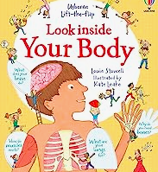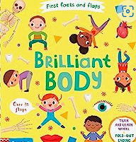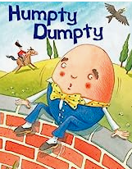

Planned investigation – Humpty Dumpty – Which landing will protect Humpty the most? (boiled egg humpty landing on different surfaces) Predicting and Investigating
Autum 2
What do we celebrate? Sparkle and Shine
There is a strong emphasis on the season Autumn into Winter in this half term. Children experience the outdoors for an afternoon each week when we use the Eco Zone for a Forest School/Outdoor learning session.
We have a big emphasis on leaves, collecting Autumn from the Eco Zone and bringing it into the classroom, noticing the leaves shapes, sizes, making collections, children experience decay happening apples rot, leaves wilt and dry out
As the weather gets colder we see naturally formed ice and frost outside we talk about how this looks and feels, we bring ice inside from outdoors and observe it as it melts and changes in a warmer place.
We use winter food – porridge and goldilocks to explore thickness and runniness by changing the amount of water – Can you make a porridge that is too thin? Can you make a porridge that is too thick? Can you make a porridge that is just right?
We talk about caring for birds – Making Bird Feeders for the birds in the colder weather- why do we need to make bird feeders at this time of year?
Planned investigations – Apple Browning Experiment putting apple in different liquids, which will stop the apple from browning observation over time.
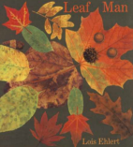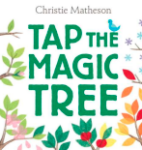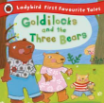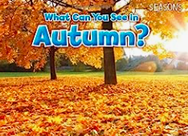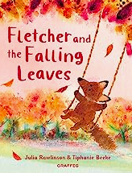

Spring 1
Where am I going and how will I get there?
This half term the children are thinking about their homes- where do I live? and journeys they make- where do I travel to? and how they get there. Through homes we make links with the three little pigs and there houses, we discuss materials and which was the strongest, through building we explore balancing and making structures. Structures – strongest structure – how to make a strong house for the pigs.
Floating and sinking – Who sank the boat? And Mr Gumpy’s Outing. Travelling on water
Forces – Duck in a truck (pushes/pulls) we also explore ramps and vehicles – falling – how things fall down ramps steep incline, small incline.
Forces in the weather – the wind (blowing) the affects of the force of the wind. The wind and the Sun story, Rosie’s Hat and The Wind blew. During this half term we can experience our coldest temperatures so we take the opportunity to explore this as it arises (sometimes the snow and ice happens here and not in the second half of the autumn)
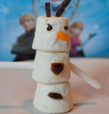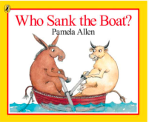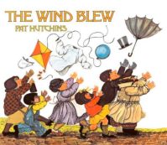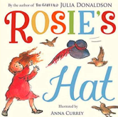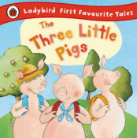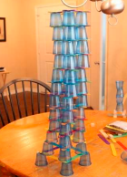

Spring 2
What do I like to eat and is it good for me?
This half term the main focus is around food and health the aspect of people, culture and community takes greater emphasis. There are many opportunities for working scientifically. Opportunities for children to explore the changes that take place during cooking (melting chocolate for easter crispy cakes) making chapatis with Mrs Zulfi. Children explore, investigate, and talk about the features of a range of fruit (skin, flesh, seeds, taste, texture, smell, size, shape. The children identify the parts that can be eaten and those that cannot. (Handa’s Surprise)
Healthy lifestyle including dental health has a large emphasis we spend a week on learning about looking after our teeth and stories about oral health. This is focussed on throughout the year, but we have a “teeth week” here. We talk about healthy bodies and healthy minds including wellbeing we talk about food groups and the importance of eating a balanced diet.
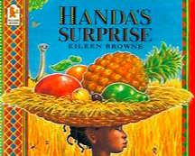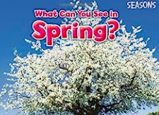

Summer 1
Are animals like me?
There is a natural world and geographical focus in this half term, we begin by looking at pets and learning about the needs of animals and compare this to humans. Do we need the same things? How are we similar/different? We then move our learning into how animals can help us and why they are important using the text “Superworm” we learn about how worms are important for the garden and composting. We also learn how dogs are used to help people with needs, we learn about sight dogs, hearing dogs, rescue dogs and therapy dogs, we complete investigations around our senses like the dogs do. Help each other move around using directional vocabulary whilst blindfolded, a smell test blindfolded and hearing/sound lotto, using our senses to guess objects from feely boxes/bags.
We learn about day and night animals and the language nocturnal, and diurnal is used children sort animals into those we might see during the day and those that are active at night. We find out about bats (or another nocturnal animal of choice) we begin work on lifecycles frogs and butterflies.
We also explore where animals live? Hot and cold places – and habitats the rock pool which creatures would you find in a rock pool (sea life trip)
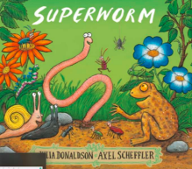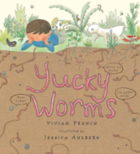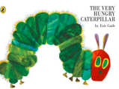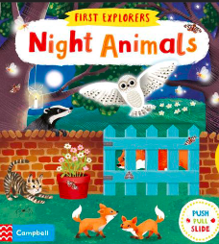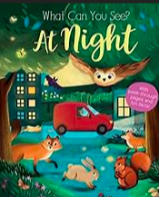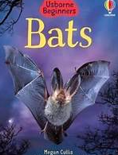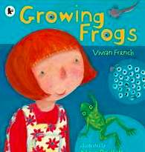
Summer 2
What does the Summer bring?
Summer is well under way in this topic so we talk about the season of summer and what it brings, noticing changes in the weather and in the environment, we talk about things we can do in the Summer that are not done at other times of the year.
We usually experience warmer weather here so we discuss and learn about the sun and sun safety – how can we be safe in the sun? We look at outdoor shadows on a sunny day, we bring this inside using torches making puppets and using objects to explore how we can change the size of the shadow. We use the story the black rabbit as an introduction to the work on shadows. We also look at rainbows when we have the sun and rain – we complete a make a rainbow experiment using coloured water mixing the rainbow using pipettes to transfer water from one mini cup to another.
We learn about minibeasts in this half term as the warm weather brings them out and they are more active in the summer (Minibeast hunts) Spiders- Incy Wincy Investigation- Which material is the best to stick Incy Wincy to a pipe so she doesn’t fall down the pipe?
We learn about the importance of bees and looking after bees and this links into work on flowers – lots of flowering plants in bloom in the Summer. “Why do flowers grow” story.
Forest school week happens in this half term with our Forest School Teacher
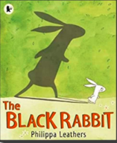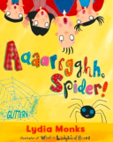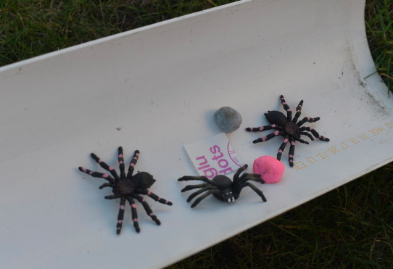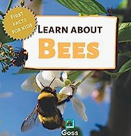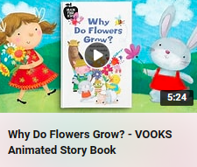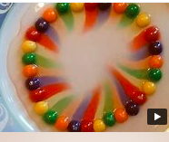
EARLY LEARNING GOAL (ELG)
Children at the expected level of development will: - Explore the natural world around them, making observations and drawing pictures of animals and plants; - Know some similarities and differences between the natural world around them and contrasting environments, drawing on their experiences and what has been read in class; - Understand some important processes and changes in the natural world around them, including the seasons and changing states of matter.
This sets out possible learning and intentions our plans are flexible as our children’s learning is often driven by their interests and certainly planned around their needs.

