Educational Programme for Understanding the World | 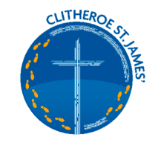  KNOWLEDGE AND UNDERSTANDING OF THE WORLD  HISTORICAL DEVELOPMENT  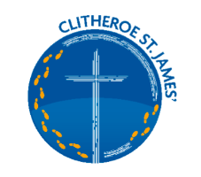
Understanding the world involves guiding children to make sense of their physical world and their community. The frequency and range of children’s personal experiences increases their knowledge and sense of the world around them – from visiting parks, libraries, and museums to meeting important members of society such as police officers, nurses, and firefighters. In addition, listening to a broad selection of stories, non-fiction, rhymes, and poems will foster their understanding of our culturally, socially, technologically, and ecologically diverse world. As well as building important knowledge, this extends their familiarity with words that support understanding across domains. Enriching and widening children’s vocabulary will support later reading comprehension.
Key Learning Linked to Past and Present – Historical Development

• Communication – talk about key events, in own lives, about family, friends, other people including significant people. Talk about key roles people have in society both in the present and the past.
• Observe – show an interest in significant events and experiences in the lives of others, including friends and family members, and through books.
• Describe – features of objects, people, places at different times, make comparisons. Talk about what is the same and what is different.
• Research – find out about, people, places, events, objects, ask questions, use different sources to find the answers, including books.
• Recall – talk to others about what they know about a key person, character, event from the past.
• Chronology – order simple experiences in relation to themselves, and others including stories, events, and experiences.

• Vocabulary – use the language of time when talking about past/present events in their own lives and in the lives of others including people they have learnt about through books.
Today, yesterday, tomorrow, morning, afternoon, evening, last week, this week, next week, last night, this morning.
Old, new, then, now, past, future, before, after, birthday, next.
Summer, Winter, Spring, Autumn, long ago, while, week, year, month, last, hour, back, clock, during, breakfast, lunch, dinner, supper, season, calendar, night, day.
Holiday, celebration, Christmas, Easter, Eid, Diwali, Bonfire Night.
Language to help understand the concept of change- old and new, historic, traditional, vintage, old-fashioned, ancient, antique, well used, worn, mended, shabby, innovative, cutting edge, novel, latest, current, bright, fresh, sparkly, shiny, modern, recent, up to date.

Key Questions
When do you get up? When do you go to bed? Can you think of things you do at different times of the day? Week? Weekend? Are all of the days the same? What is different? What happened the next day/day before?
Looking at objects: what does it look, feel, smell like? What do you think you might do with it? How would you….? What is it made of? Have you seen anything like it before? What happens if? Can you? Why? How is it different? What do you notice about the old/new?
Looking at pictures in books or photographs: what can you see? What do you think? Can you see any people in the picture? What are they doing? What are they wearing? Are their clothes the same as yours? What do you notice that is different?
What this Looks like in EYFS
Autumn 1
Where do I belong? Me and my world
The aim is for children to talk about their lives, they belong to their family, they have belonged to pre-school/nursery and now they belong at school and they will experience changes as they grow.
Children talk about events in their own lives, talk about family members, talk about friends’ old friends and new friends. Children will be encouraged to show an interest in the lives of others. Talk about day-to-day life for them. Talk about significant past and present events. Create a family collage or a how I have changed timeline. How have the children changed since they were babies. What did I wear when I was a baby? What did babies wear in the past? (Possible museum Loan) compare two items talk about similarities and differences.
What happens during our day at school? Sequencing events, learning daily routines and being able to talk about them.
Retelling and sequencing events in stories.
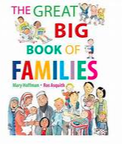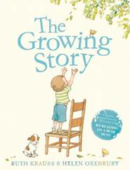
Autum 2
What do we celebrate? Sparkle and Shine
The aim in this half term is to begin to observe and talk about changes in the seasons we are into Autumn and seeing changes in the environment. The term begins with Autumn an Autumn walk and a discussion about the season. This leads into celebrations in Autumn – Bonfire night, Guy Fawkes, Remembrance Day, Diwali, and leading up to Christmas we focus on birthdays in preparation for our Christmas celebrations (birth of Jesus and Nativity). The children will talk about Guy Fawkes and learn that he is a figure from the past and the events that occurred that are the reason we have bonfire night. We talk about remembering, what do we remember from the past. We discuss that we can have good, pleasant memories and bad/unpleasant memories. We complete a creative activity with poppies and the children recall a memory for us to write on their poppy art. We talk about the significance of the poppy. We begin our work on birthdays, why do we celebrate our birthday? How do we celebrate? We plan a birthday for “Fred the phonics Frog” we plan the event, sequencing what we need to do, first, next, and finally. We then lead up to Christmas with a comparison of old toys and new toys (possible museum loan artefacts) and Christmas Traditions from the past and talk about how Christmas is celebrated.
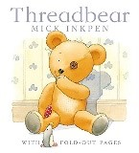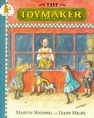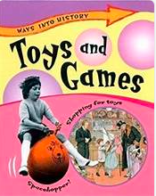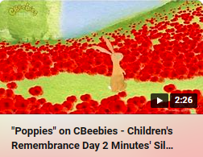

Spring 1
Where am I going and how will I get there?
This half term the children are thinking about their homes- where do I live? and journeys they make- where do I travel to? and how they get there. There is a focus on the local area and their home and school. Although the major focus here is geographical. There are opportunities for learning linked to historical development. What is our school like and has it changed? Looking at photographs and looking for changes in the school uniform over the years and how have people changed (different members of staff, and how have staff changed, aged) What is your house like? We look at the story Peepo- A story set in a home in the 1940s what is the same and what is different?
Having Clitheroe Castle on the doorstep is a perfect opportunity to explore the idea that in the past the Castle was a home and now it is a ruin. Who lives in a castle? Who lived in Clitheroe castle? Begin to talk about Lords, Ladies, Kings and Queens and there is an opportunity to talk about the Royal Family – finding out about the Prince and Princess of Wales and their family.

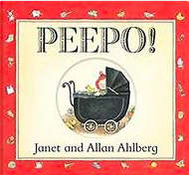

Spring 2
What do I like to eat and is it good for me?
This half term the main focus is around food and health the aspect of people, culture and community takes greater emphasis. There are opportunities for historical development when making comparisons between the way we cook now and how people have cooked in the past. Sequencing when looking at recipes and making food, what comes first, next, after that- using Language of the passing of time and sequencing in stories. Spring is well under way in this half term so changes can be observed and growing can be observed – planting and observing changes over time in germination of seeds.
Influential figure, significant people – Marcus Rashford – Campaign to make sure no child is hungry.
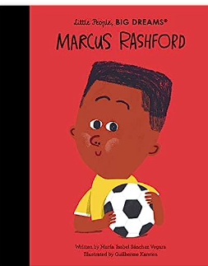

Summer 1
Are animals like me?
There is a natural world and geographical focus in this half term but in the life cycles work using the Hungry Caterpillar story there is a opportunity to reinforce the days of the week, sequence and order.
Significant individuals Gretta Thunberg – environmental activist
David Attenborough- talk about his life broadcaster and conservationist.

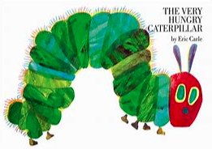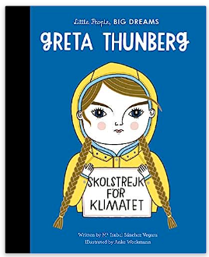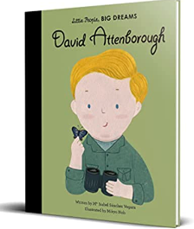

Summer 2
What does the Summer bring?
Summer is well under way in this topic so we talk about the season of summer and what it brings, noticing changes in the weather and in the environment, we talk about things we can do in the Summer that are not done at other times of the year. Holidays allow for discussion of children’s experiences, holidays they remember and holidays they are looking forward to. Sports day happens this half term, so this creates an opportunity to look at illustrations and pictures from the of Summer fair and Sports day in the story Dogger- Shirley Hughes. We also talk about Summer bringing the opportunity for picnics and this leads into Teddy Bears Picnic and an opportunity to look at Teddy Bears- Comparing old and new bears – Favourite teddy bears Teddies in history – Rupert, Paddington, Winnie the Pooh, Old Bear- Teddy Bears Picnic Song from (1932) listen to and enjoy. Discuss the theme and ideas in the lyrics.
Transition Memories from the Year discussing what the children have enjoyed, what can they remember? The future looking forward to a new class.
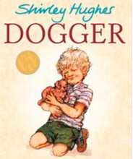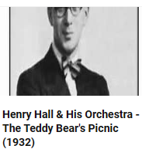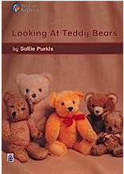
EARLY LEARNING GOAL (ELG)
Children at the expected level of development will:
- Talk about the lives of the people around them and their roles in society.
- Know some similarities and differences between things in the past and now, drawing on their experiences and what has been read in class;
- Understand the past through settings, characters and events encountered in books read in class and storytelling.
This sets out possible learning and intentions our plans are flexible as our children’s learning is often driven by their interests and certainly planned around their needs. We also acknowledge events that cannot be planned for in advance for example, the Coronation of King Charles was planned in and Remembering Queen Elizabeth on her passing. Any opportunity to make links to historical development are taken throughout the year.

