

**K**ey **I**nstant **R**ecall **F**acts

Spring Term 2

Oak Class

By the end of this half term, children should know the following facts. The aim is for them to recall these facts **instantly**.

**Count on and back in 10’s**

10,20,30,40,50,60,70,80,90,100

**Number bonds to 20**

e.g

2 + 18 = 20

12 + 8 = 20

15 + 5 = 20

**Key Vocabulary**

* Measure
* Length
* Height
* Shorter
* Longer
* Taller
* Heavier
* Lighter

**Children should also be able to count on and back from any number up to 50.**

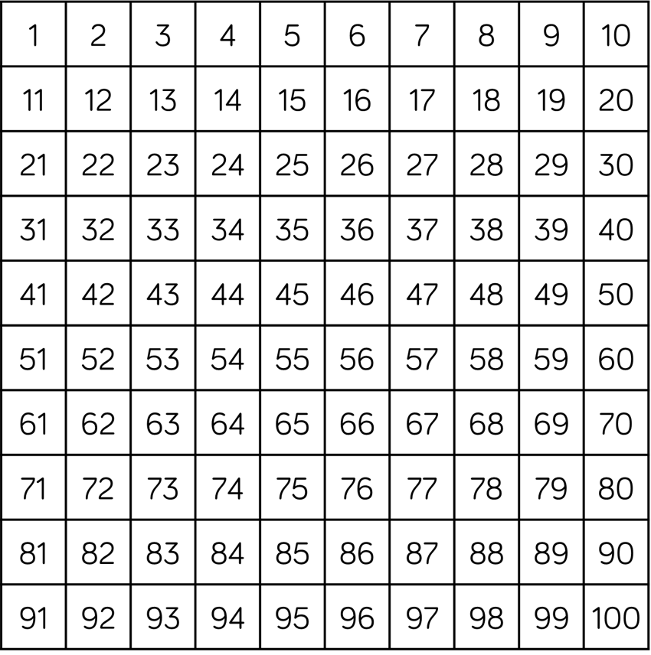

**Top Tips**

The secret to success is practising **little** and **often**. Can your child practise these KIRFs while walking to school or during a car journey? They do not need to practise them all at once; perhaps you could have a fact of the day. If you would like more ideas, please speak to your child’s teacher.