Key Instant Recall Facts
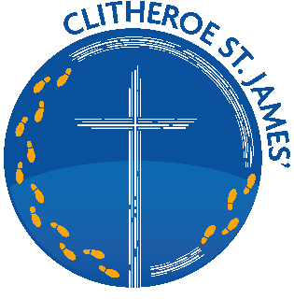
(KIRFs)
Spring Term 2
EYFS

By the end of this half term, children should know the following facts. The aim is for them to recall these facts instantly.
Zero and ten make ten.
One and nine make ten.
Two and eight make ten.
Three and seven make ten.
Four and six make ten.
Five and five make ten.
I can partition numbers, to 10, into two groups

Top Tips The secret to success is practising little and often. Use time wisely. Can you practise these KIRFs while walking to school or during a car journey?
Use practical resources –
• Using items around the house to find different ways of making 10, e.g one blue teddy and nine red teddies. One and nine make ten.
• Making up stories with items around the home, e.g there are 2 cars in the car park and 8 more cars arrive, how many cars altogether? Two and eight make ten.
• Asking questions during daily routines, e.g you have 4 sausages on your plate and I have 6 sausages on my plate, how many sausages altogether? Four and six make ten.
https://www.bbc.co.uk/iplayer/episode/b0bn5k6h/numberblocks-series-3-ten-again
